Q1)

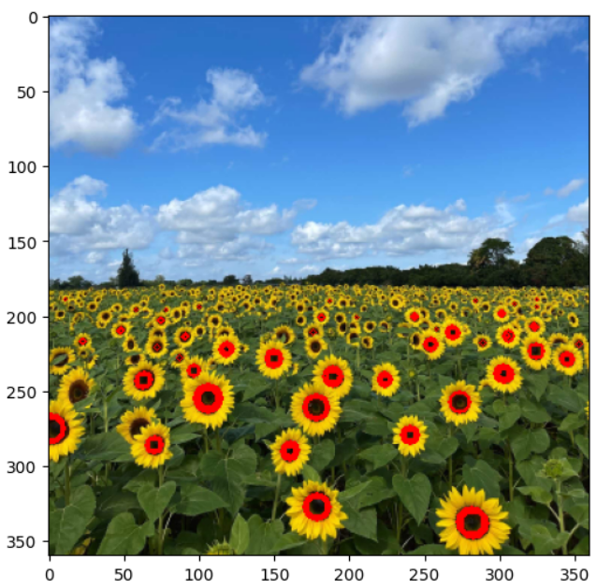The parameters of the largest circle are:   
(207, 323)  
sigma value correspond to the maximum response : 2  
radius : 2

Q2) (a)Line Fitting using RANSAC

(b)Circle Fitting using RANSAC  
  
  
(c) Plotting Line and Circle

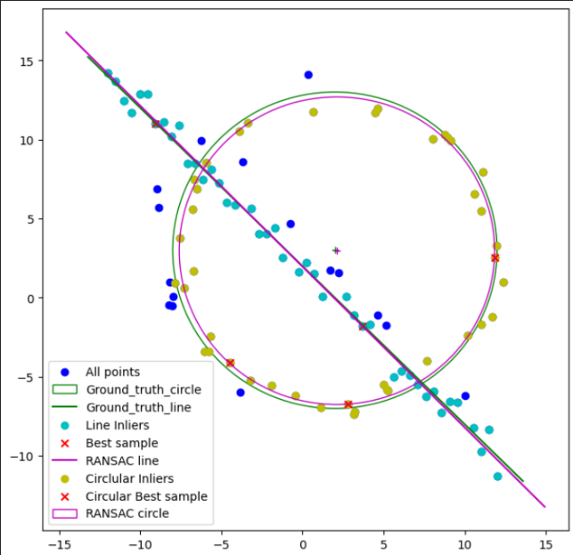

d) When circle is first modeling using RANSAC, It can be taken the line inlier points as inliers to the circle and can predict a circular model which has a large radius. Then when the line model is predicting, due to the lack of inliers points, line prediction could be inaccurate. Therefore it is better to prioritize the dominance model when fitting.

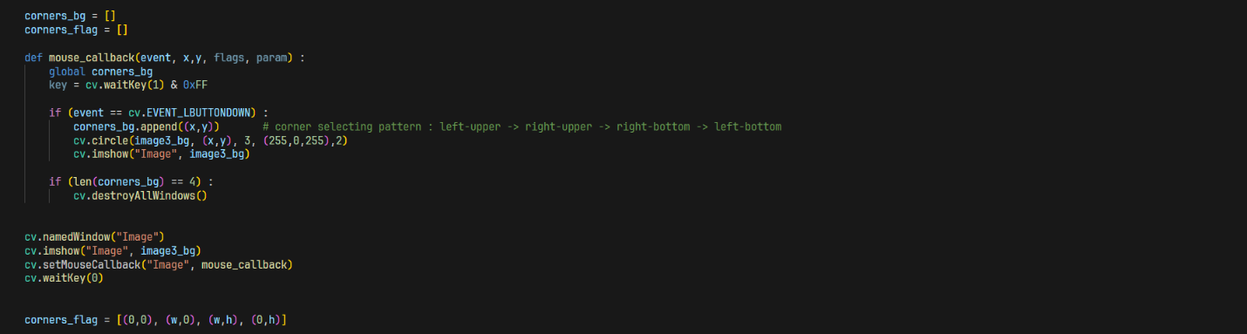Q3)

Q4)

